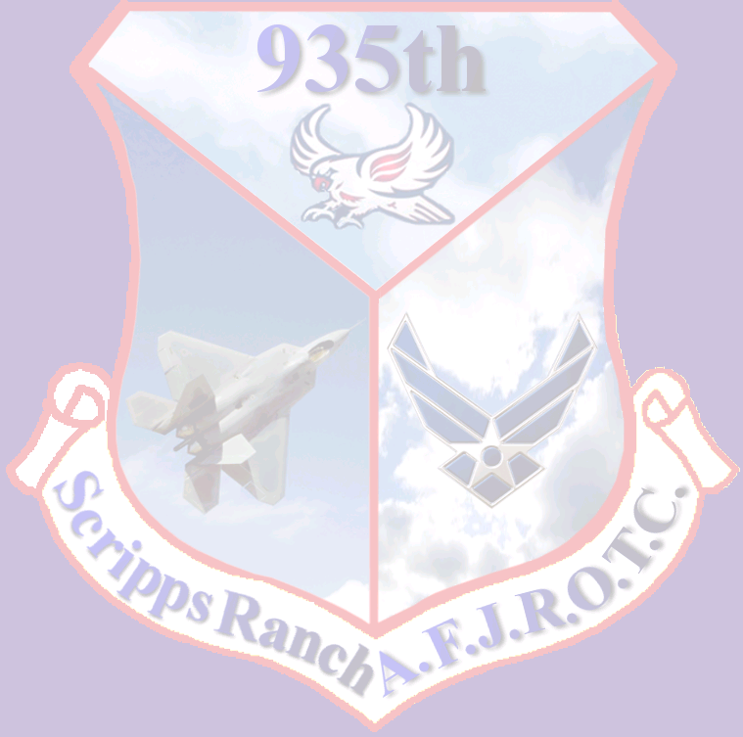
CA-935th MARCH-APRIL 2011 NEWSLETTER

A DIFFERENT KIND OF BDI
On March 6th, Color Guards and Armed Drill Teams from JROTC units across San Diego Unified School District gathered at Kearny Mesa High School for the annual Brigade Armed Best Drilled Individual (BDI) and Color Guard Competition.
At 0830 c/2d Lt Chris Nguyen and c/A1C Kahan Robinson reported to their respective BDI pads, followed by c/MSgt Sokly Heng and c/2d Lt Darrione Soriano later in the day. There were three phases that each BDI participant had to go through which were inspection, stationary drilling, and non-stationary drilling. In the end, cadet Robinson earned 2nd Place
First-Year BDI. He was the only BDI from Scripps Ranch to place in the top-three within his respective year.
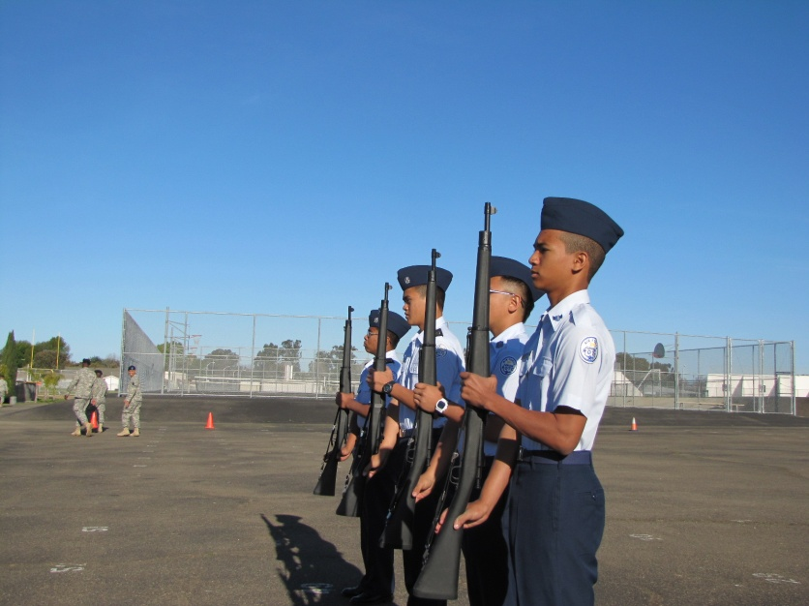
c/SrA Michelle Parker commanded the Freshman Color Guard to the First-Year Color Guard Pad. They were the first to go up at 8:30 am. Parker and her team set the bar high for other teams, remaining cool under pressure and her military retaining bearing through the entire routine. Meanwhile, c/Capt Zucker.
c/SrA Michelle Parker commanded the Freshman Color Guard to the First-Year Color Guard Pad. They were the first to go up at was instructed to fall in his team earlier than scheduled. Despite this, the team performed phenomenally, sharply executing commands with military precision. In the end, the
Color Guards blew the competition away, with both details attaining 3rd place on their respective pads.
At the end of the day, Scripps Ranch High School’s Armed Team and Color Guard made their resident Brigade Staff members, c/Col Kevin Huynh and c/Maj Allen Tran proud. Their winnings contributed to Scripps Ranch High School’s steady run for first place in the annual Stillwell competition that, if we win, will distinguish our unit as the best in the district.
Color Guards blew the competition away, with both details attaining 3rd place on their respective pads.
c/2nd Lt Jose Cuevase

80 DOLLARS GOES A LONG WAY
On April 5th through 6th during spring break, 38 AFJROTC cadets traveled to Edwards Air Force Base for an orientation visit.
Every cadet in CA-935th that paid to go Edwards Air Force Base and Six Flags Magic Mountain met outside the JROTC Room at 3 am, sleepy and in uniform pants and shoes, with a civilian shirt and jacket. The cadets were given twenty dollars each from Sgt Toledo for whatever they wanted to purchase during the two day trip. When the bus came at 4 am, the cadets began to load their belongings onto the bus and prepared for what they knew would be an exciting experience they will never forget.
At 4:30, the bus departed from the Scripps Ranch High School. Four hours later, we stopped outside of the Edwards Air Force Base and departed our coach bus to change into full uniform. An Edwards Air Force Base military bus arrived; after boarding the new bus, it took us to the next destination. Throughout the day cadets visited various sites on Edward Air Force Base. Our first stop was the National Aeronautics and Space Administration (NASA) Space Center. They saw aircraft that have not been viewed by the public yet!
Afterwards, the cadets visited a museum that housed many replicas of aircraft, timelines of aviation history, a uniform of an important Air Force officer, and a huge painting of Edwards Air Force Base with military aircraft shown flying over the base. Lastly, they visited the Military Dog Training Facility and learned how dogs are raised to be able to find drugs and attack threatening people on command.
Afterwards, cadets went to shop and eat at the Base Exchange. At 5:30, they boarded the bus and went on their way to Motel 6. When c/2nd Lt. Jennifer Ngo was asked what she thought of the trip to Edwards Air Force Base and what her favorite thing was, she responded, “I think the trip was pretty fun! We got to see the top secret flight-line that we weren't allowed to take pictures of, or else they'd confiscate our cameras. My favorite part was seeing the Security Forces’ Work Dog take down one of the training officers and seeing how hard the dog bit, even though the guy was wearing a heavy bite suit.” After a long day, the cadets ate dinner, showered, played in the pool, socialized and turned in to their beds at 10 pm. The next day at 0730 the cadets dressed up in their casual civilian attire and prepared themselves for a fun day ahead at Six Flags Magic Mountain!
At 10:00 am, the cadets arrived at Six Flags Magic Mountain and were told to meet back at the bus at 6 pm. Throughout the day, cadets rode thrilling rollercoasters such as Goliath, Riddler’s Revenge, X2, Superman, etc. Cadet A1C Kiana Hallinan bungee-jumped and bought the DVD to commemorate her act of bravery. After riding many rollercoasters and eating great food, the clock struck 6 and it was time to board our bus for the final time.
During the bus ride back to Scripps Ranch High School, c/A1C Kiana Hallinan played the DVD of her bungee-jumping experience for the rest of the cadets to enjoy and after viewing the video, c/2nd Lt Darrione Soriano stated, “I couldn’t stop laughing at her little spasm at the time of the drop!” The cadets arrived at the school where their parents were eagerly waiting for the cadets’ return. “All good things must come to an end” is especially true for this experience that these cadets will never forget.
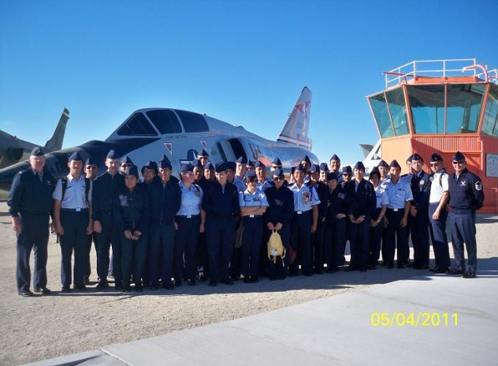
c/2nd Lt. Darrione Soriano

AROUND THE WORLD
On the evening of March 26th, cadets gathered at Town and Country Hotel in Mission Valley for the Annual JROTC Military Ball. The Ball, with an “Around the World” traveling theme, was a spectacular event that united JROTC cadets in the brigade for an evening filled with fun, food, and dance.
Appropriate attire and good manners were stressed beforehand for this event. It called for male cadets to be dressed up in service uniform and ladies in dresses. Each cadet went over with their flight commanders on proper etiquette at the dinner table, learning which utensil to use for what dish and where it is supposed to be placed.
However, the pressure to remain formal was well worth this exciting event. Cadets arrived at the hotel around 1800 hours, where they had the opportunity to have their photo professionally taken with friends, with their date, or individually. The

photographers allowed for pictures taken well throughout the night.
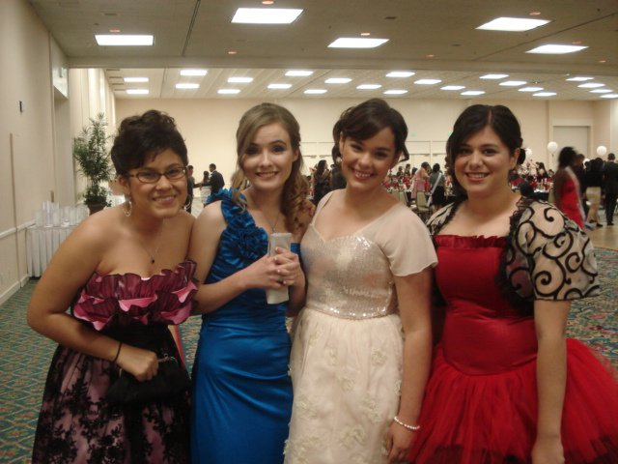
When the doors to the main hall opened, cadets were greeted with artfully crafted centerpieces and nametags, done by each school’s Centerpiece Committee. Their designs were eventually submitted to a contest to see which centerpiece best represented the theme.
Dinner was served at 1930. The guests enjoyed bread, salad, chicken or pasta, and chocolate cake. For drinks there was water, coffee, and tea. Energetic conversations also took place between cadets, instructors, and people from other schools. After dinner the colors were presented, followed by c/Col. Kevin Huynh and the superintendent of San Diego Unified School District gave speeches to the brigade and the presentation of the royal court. Guests were then allowed to relax and hit the dance floor to dance and socialize until the Ball ended at 2300.
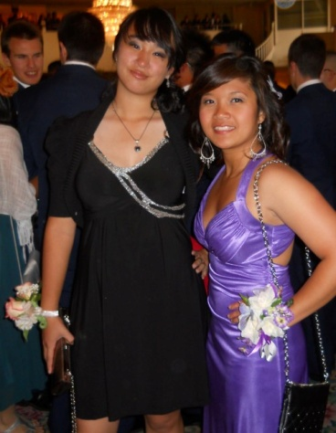
Overall, it was a fun and exhausting evening which left many cadets cheerful. “At the end I was restless, happy, and energetic,” states

c/Ryan Antonio. “I didn't want to stop dancing!”
c/2d Lt. Bey

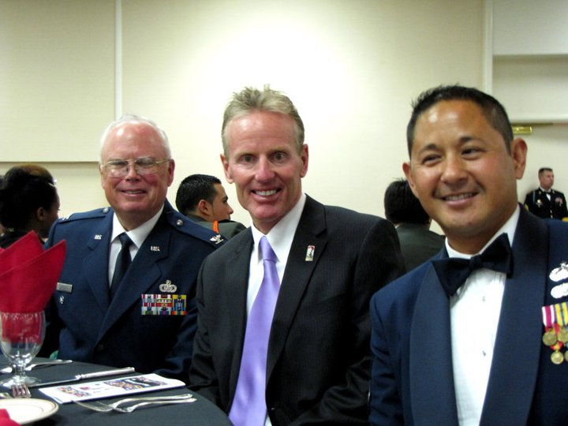

A WEEK FOR THE KIDS
On the second week of March, cadets took time from their busy schedules to go to local schools and demonstrate both important social skills and what it means to be in our corps.
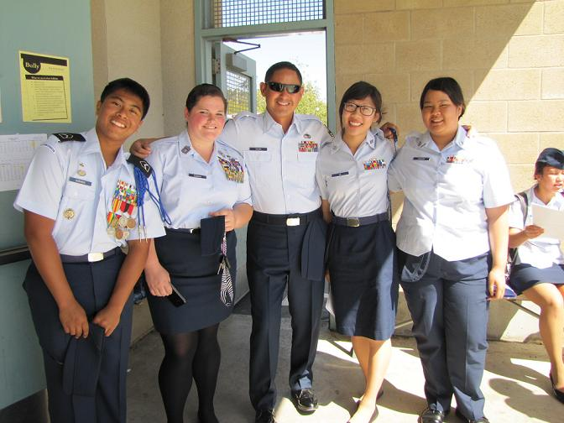
March 9th was the Awareness Presentation Team’s (APT) second round of teaching lessons in conflict and resolution. Cadets Rachel Connor, Diana Thavong, Taylor Bey, Priscilla Ly, Alyssa Yabut, Darrione Soriano, Megan Smith, and their commander c/2nd Lt. Jennifer Ngo along with MSgt Toledo drove to Hage Elementary School to meet the awaiting 4th and 5th graders. APT was divided into two teams. They each had the same presentations discussing the origins of conflict and offered cooperative ways to solve them. There was even some acting involved: cadets acted out situations and demonstrated how to resolve a problem. At the end, the kids were rewarded with San Diego Padres memorabilia if they answered questions correctly. “APT was both a learning and fun experience,” says Ngo. “All of our cadets were brand new to APT and all of us had never been to an APT presentation before, so we were all nervous but it turned out well!”
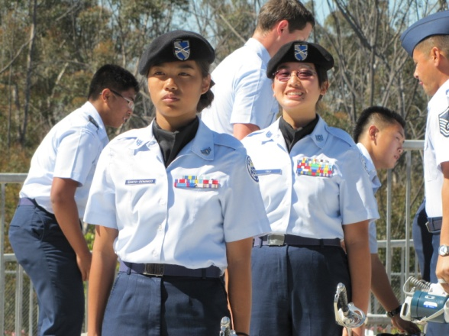
The following day, team members handpicked by their commanders went to Marshall Middle school to find some potential new cadets for next year. Team demonstrations were performed by the Armed, Unarmed, and Saber teams, hoping to impress the Marshall students during their lunchtime. Saber team member, cadets Erica Santo Domingo and Cameo Tsui, for example, performed a saber dual for the students. “The kids at Marshall were very impressed by our performances,” states Santo Domingo. “We might have a lot of incoming freshmen next year!” Over megaphone, Sgt. T described what CA-935th has to offer, including the teams.
These events were not only enjoyable and interactive, but also significant to attracting potential new recruits to our corps. Hopefully there will be some familiar faces in the crowds of freshmen joining our JROTC unit in years to come.
c/Taylor Bey

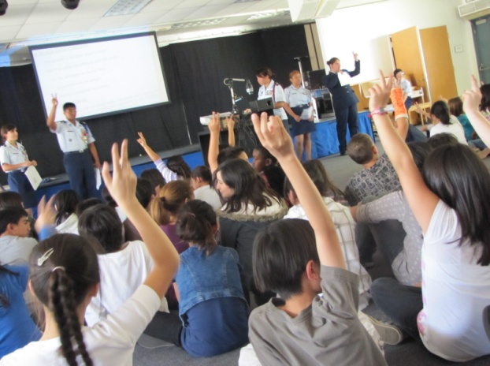

CADETS GIVE OUT POPPIES AND SMILES FOR VETERANS
Although the Buddy Poppies weren’t real, artificial ones were given out by volunteers of the Veterans of Foreign Wars (VFW) to raise awareness for their cause. Veterans of the Foreign Wars is an organization that provides various aid and various assistance programs to veterans and their families. Cadets Soriano, Ngo, Salinas, Cuevas, Wang, Santo-Domingo, Talde, Connor and Mortazavi, volunteered with VFW on April 3rd, 2011 at MCAS Miramar Base.
The cadets in their uniforms stood in front of the Commissary and Base Exchange, requesting donations and passing out small “Buddy Poppies” to the patrons and small American flags to the kids. This seemed difficult at first for those cadets who were shy, but within the hour, they came out of their shell with big smiles on their faces, knowing that the donations they had received from the people would go to a good cause. This event does not only helped disabled veterans. Since there was a surplus of funds, the veterans running the MCAS Miramar charter of the VFW also donated some money to our corps. c/Soriano, in charge of this event, stated the following: “I feel that our corps raised a lot of money to help the VFW, and we made an impact on the lives of many veterans that benefited from our services. I am happy that the cadets did a good job this year and hope they participate in future Buddy Poppy events.”
Next time the signup sheet comes up for this event, do sign up! Not only does it help our corps and help veterans, it is a source of community service hours and lets the cadets know that they did a service that benefits the people who sacrificed their lives for the United States of America.
c/2d Lt Jennifer Ngo

FOOD FOR FUNDS
February 26th was a gloomy and rainy day, but that did not stop cadets, their families, and their friends from warming up their hearts and their stomachs at Applebee’s restaurant early in the morning. The restaurant was temporarily closed to the public to host a CA-935th AFJROTC fundraiser, offering a “buffet-style” breakfast for those that purchased tickets. Tickets were 10 dollars each, with half of the profit going to the restaurant and the other going to the unit to be used for future JROTC events.
c/Capt. Kariza Labrador cheerfully greeted guests as they walked in from the cold and took their seats. It took a while, but eventually Applebees’ staff brought out fresh pancakes, scrambled eggs, and sausages for Booster Club members and Senior Staff to serve up. Everyone had plenty of food, as well as the chance to meet new people and socialize. “It's fun having a conversation with everyone and getting to know your friends’ families,” states c/SrA Michelle Parker.
This event brought in significant funds for CA-935th, with over 700 dollars being added to the budget for group events, competitions, and other activities. There will be future events like this one, such as the Hometown Buffet fundraiser on May 30th, so sign up and support our corps!
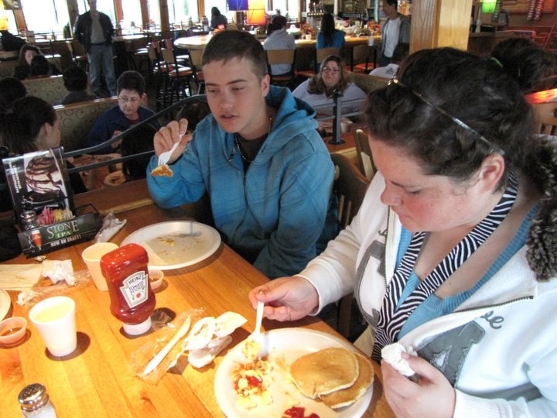
c/2d Lt. Bey

